Alice in Wonderland, Lesson 3 ‘A Mad Tea Party’ HAVO/VWO
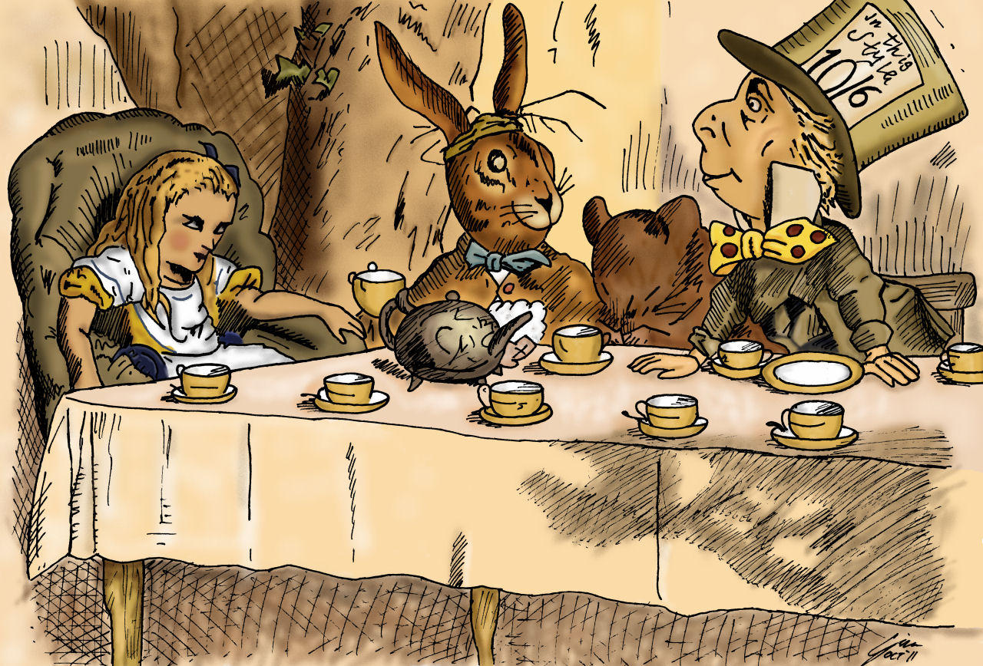

- Before you start reading the story, have a brainstorm about ‘A Mad Tea Party’ write down what you think about when you here the title.
-
- Read the text ‘Alice in Wonderland, Chapter 3’ and write down 20 difficult words with their translation.
English | Dutch | English | Dutch

- Answer these questions about the text.
- Why does de March Hare offer Alice some wine?
-
- Explain the differences between these sayings (give your answer in Dutch):
- ‘I see what I eat’ vs ‘I eat what I see’:
- ‘I like what I get’ vs ‘I get what I like’:
- ‘I breathe when I sleep’ vs ‘I sleep when I breathe’:
- Why is the watch wrong? What has happened to it?
-
- Explain why it’s always tea-time for the Mad Hatter and the March Hare.
-
- As Mad as a Hatter
- Read this description about being “Mad as a hatter”.
"Mad as a hatter" is a colloquial phrase used in conversation to refer to a crazy person. In 18th and 19th century England mercury was used in the production of felt, which was used in the manufacturing of hats common of the time. People who worked in these hat factories were exposed daily to trace amounts of the metal, which accumulated within their bodies over time, causing some workers to develop dementia caused by mercury poisoning (called mad hatter syndrome). Thus, the phrase became popular as a way to refer to someone who was perceived as insane.
- Explain, in your own Dutch words, how this expression originated.
-
Riddles HAVO/VWO
- The Mad Hatter tells a riddle in this story. What is a ‘riddle’?
-

- Go to https://www.atagar.com/riddles/ and try to solve a couple of riddles.
If the riddles are too difficult to solve you can press the ‘reasoning’ button to help you solve it.
HAVO: Solve at least 2 Easy riddles and 2 Medium riddles.
VWO: Solve at least 1 Easy riddle, 2 Medium riddles and 1 Hard riddle.
Walt Disney’s version HAVO
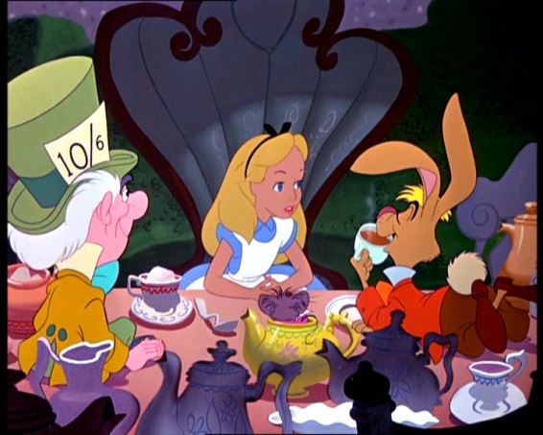
- Have a look at Walt Disney’s interpretation of the Mad Tea Party and answer the questions.
https://www.youtube.com/watch?v=6zxFlrxdwyY
- Write down 3 similarities between the story and the clip.
-
-
-
- Write down 3 differences between the story and the clip.
-
-
-
- Explain in your own words what an ‘unbirthday’ is.
-
- How many cups of tea does Alice drink during the Tea Party?
-
- Why does the Dormouse freak out?
-
- The White Rabbit’s watch seems to be broken. What does the Mad Hatter think is wrong with it?
-
- Why does the Mad Hatter think it’s silly to put mustard in the watch?
-
- Why is the White Rabbit extra sad about his watch?
-
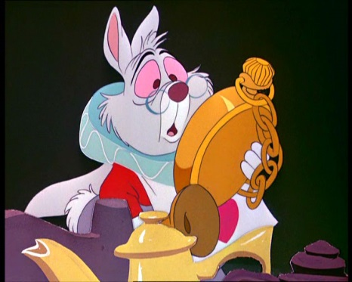
Walt Disney’s version VWO
- Have a look at Walt Disney’s interpretation of the Mad Tea Party and answer the questions.
https://www.youtube.com/watch?v=6zxFlrxdwyY
- Write down 3 similarities between the story and the clip.
-
-
-
- Write down 3 differences between the story and the clip.
-
-
-
- Explain in your own words what an ‘unbirthday’ is.
-
- Explain what Alice means when she says ‘I haven’t had any yet, so I can’t very well take more’.
-
- Write down 5 things that prove that this is indeed a ‘mad’ tea party.
-
-
-
-
-
- The White Rabbit’s watch seems to be broken. How does the Mad Hatter try to fix it?
-
- What is wrong with the mustard?
-
- Why is the White Rabbit extra sad about his watch?
-

